**IDEATION PHASE:**

|  |  |  |  |  |
| --- | --- | --- | --- | --- |
| **S.NO** | **TITLE** | **MODEL / TECHNIQUES USED** | **MERITS/ DEMERITS** | **OUTCOMES** |
| 1. | Arindm Ghosh, Debajyoti Sarkar (2022),“Design and Fabrication of IoTbased Smart Dustbin” International Journal for Research in Applied Science & Engineering Tchnology | ARDUINO,  BLUETOOTH | **MERITS:**  Level indication enables timely pick up of wastes without overflowing | Automatic level indication and alert is sent via bluetooth to the authority(only for short range) |
| 2. | Akshayaa S, Evangiline R (2021), “Smart bin for Clean cities using IoT”, International Conference on Advanced Computing & Communication Systems | Arduino UNO,  MATLAB, BYLNK APP | **MERITS**  Reduced level iof risk , Easy access of bins remotely | Gesture based opening and closing of garbage bin lids  which prevents risk of infection |
|  | Upasana Sapra, Gayathri D (2019), “Efficient IoT based smart bin for waste management and disposal” ,Internatiosnal Journal of Informatics and Computer Science | Raspberry Pi Zero ,USB Camera module | **MERITS**  Eco-friendly, Easy monitoring (less effort).Easy interface | This project aims at timely pick up of wastes and easy accessing of dustbins remotely. |

**LITERATURE SURVEY:**

**EMPATHY MAP:**

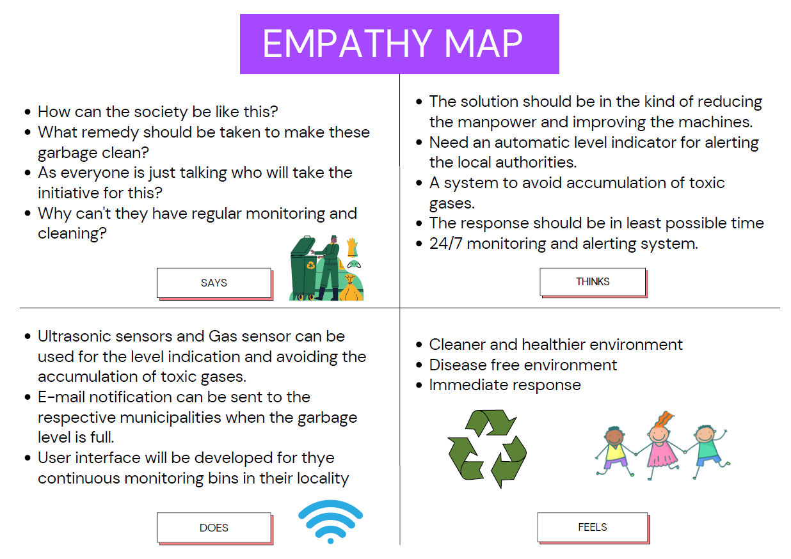

**BRAINSTORMING:**

